**Project Design Phase-II**

**Data Flow Diagram & User Stories**

|  |  |
| --- | --- |
| Date | 26 June 2025 |
| Team ID | SRGECVIP20251570 |
| Project Name | Revolutionizing Liver Care : Predicting Liver Cirrhosis using Advanced Machine Learning Techniques |
| Maximum Marks | 4 Marks |

**Data Flow Diagrams:**

A Data Flow Diagram (DFD) is a traditional visual representation of the information flows within a system. A neat and clear DFD can depict the right amount of the system requirement graphically. It shows how data enters and leaves the system, what changes the information, and where data is stored.



**Example:** [**(Simplified)**](https://developer.ibm.com/patterns/visualize-unstructured-text/)

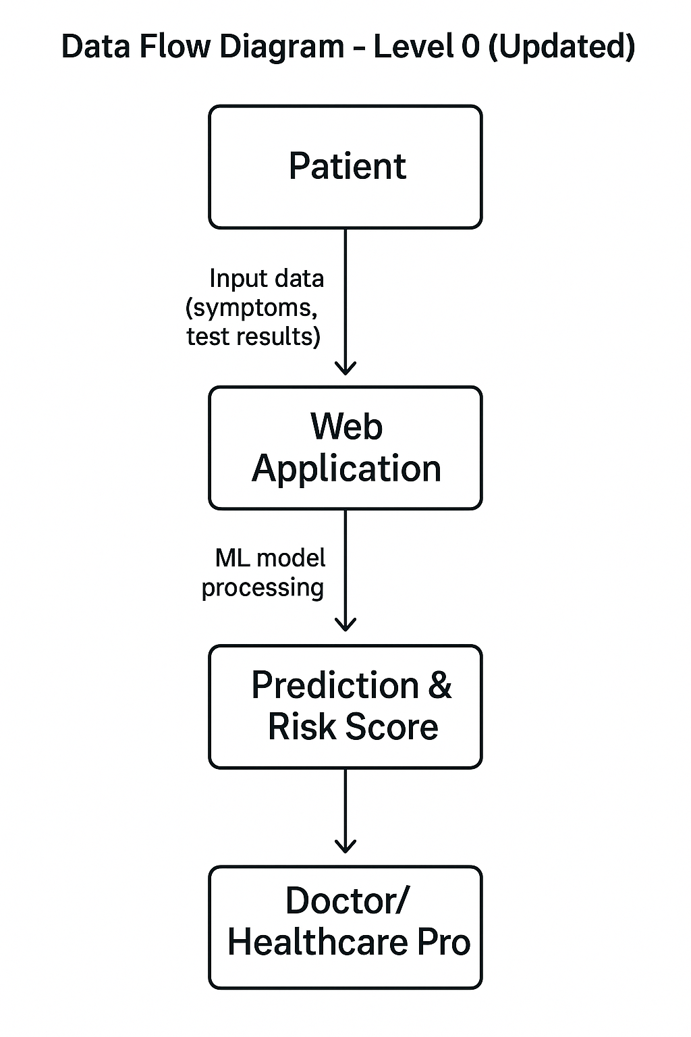

User Stories (Customer-Centric)

|  |  |  |  |  |  |  |  |  |  |  |  |  |  |  |  |  |  |  |  |  |  |  |  |  |  |  |  |  |  |  |  |  |  |  |  |  |  |  |  |  |  |  |
| --- | --- | --- | --- | --- | --- | --- | --- | --- | --- | --- | --- | --- | --- | --- | --- | --- | --- | --- | --- | --- | --- | --- | --- | --- | --- | --- | --- | --- | --- | --- | --- | --- | --- | --- | --- | --- | --- | --- | --- | --- | --- | --- |
| |  |  |  |  |  |  |  | | --- | --- | --- | --- | --- | --- | --- | | User Type | Functional Requirement (Epic) | User Story Number | User Story / Task | Acceptance Criteria | Priority | Release | |  |  |  |  |  |  |  | | Doctor (Healthcare Professional) | Diagnosis Support | USN-1 | As a doctor, I want to input patient details and get liver cirrhosis risk prediction so I can diagnose faster. | System provides accurate risk level and supporting feature insights. | High | Sprint-1 | | Patient | Early Detection | USN-2 | As a patient, I want my routine lab results to help identify liver issues early without undergoing invasive tests. | Patient receives early warnings based on clinical data. | High | Sprint-1 | | Doctor (Healthcare Professional) | Interpretability | USN-3 | As a doctor, I want to understand which features influenced the model’s prediction so I can trust the diagnosis. | Doctors can view SHAP-based explanation for each patient. | Medium | Sprint-2 | | Clinic Admin | Ease of Use | USN-4 | As a clinic admin, I want a web-based tool accessible from our clinic devices so doctors can use it without setup. | Doctors use the tool on browser without installation. | High | Sprint-1 | |